Claims Analysis

Claims analysis is a technique for examining the positive and negative consequences of design features that are described in current or future scenarios of use. A "claim" is a statement of the consequences of a specific design feature or artifact on users and other stakeholders.

Here, we observe and analyze the design features of existing dating apps and services, show pictures of them in use, describe the features, and discuss the benefits and consequences of their implementation.

List of Apps Analysed:

* OkCupid
* Tinder
* Zoosk
* PlentyofFish
* Match.com
* AnastasiaDate
* Lavalife

Profile Pages

In this picture is an example of a profile page from plentyoffish.com showing a user’s demographic information for others to see when they look at her profile page.

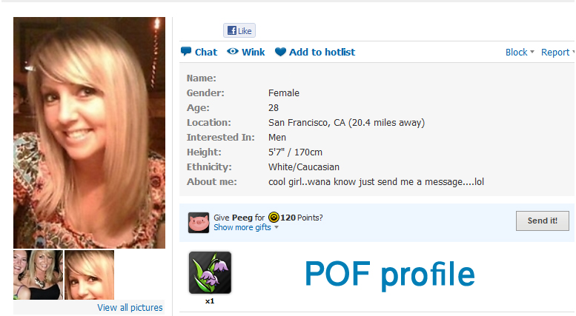

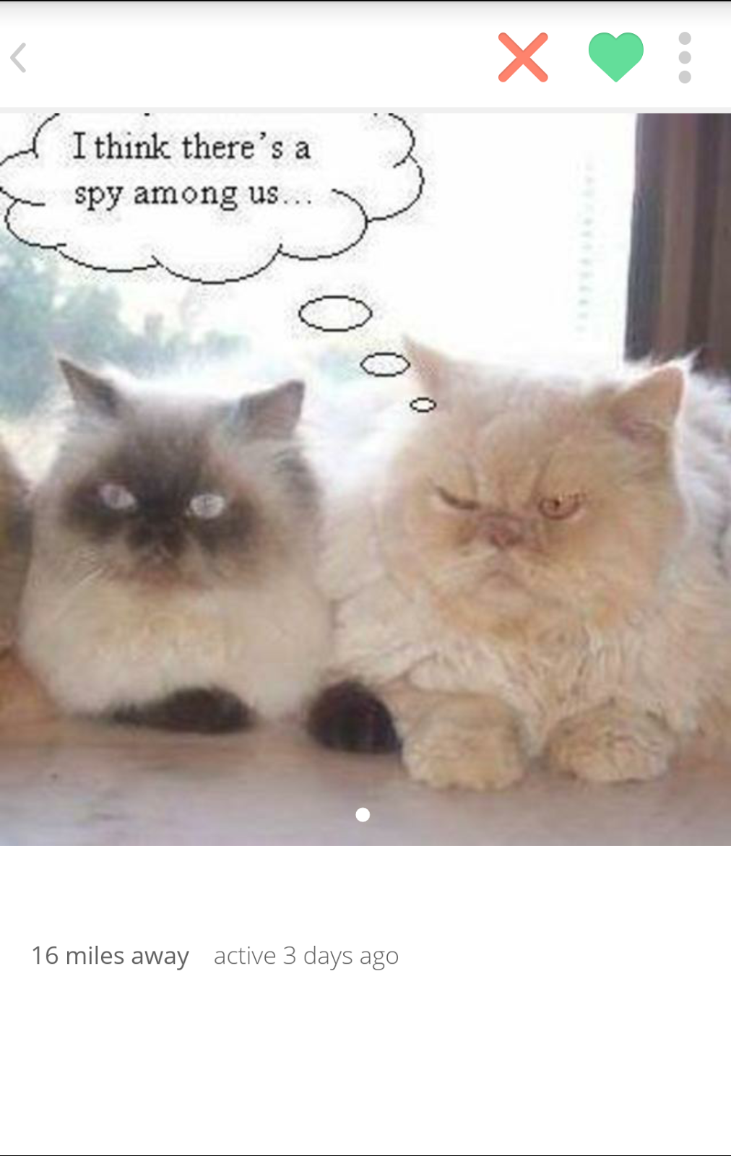 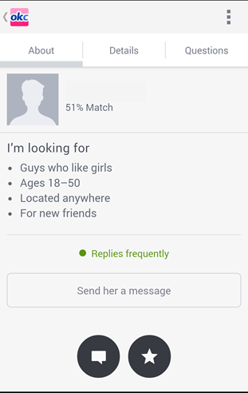

Profile pages are a user’s personal collection of their information for other users to view. It allows people who view their profile to see common information at a glance.

Apps Analyzed:

* Tinder
* OkCupid

Pros:

* Users do not have to constantly tell others their basic information
* Users can quickly learn the basic information of other users

Cons:

* Users may provide false information
* Users can misinterpret personal questions answered
* Users are limited in the first impression they make to other when compared to face-to-face interaction

User Profile Searching

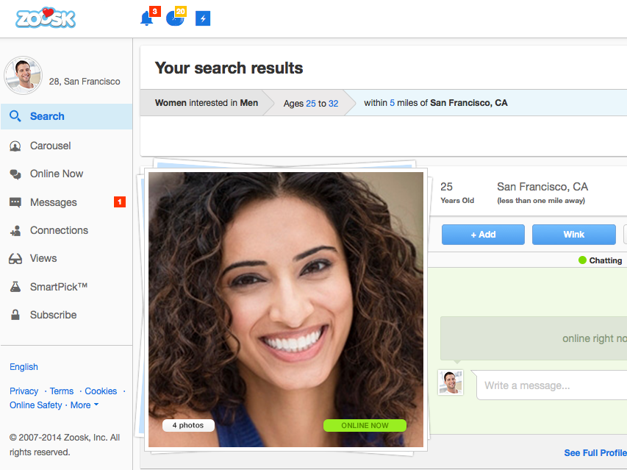

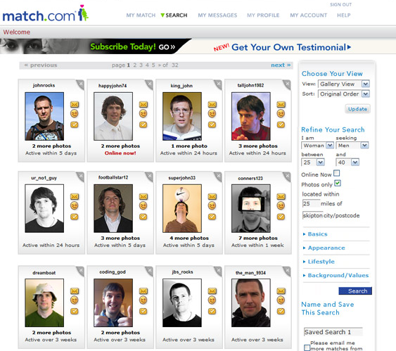

User profile searching allows users to search for other users using various different filters related to physical attributes.

Apps Analyzed:

* Zoosk
* Tinder
* Match.com

Pros:

* Able to use filters related to physical attributes
* Limit searches to more desirable profiles based on the users preferences

Cons:

* The search is limited to physical appearance, factors like sense of humor cannot be searched
* It can take more time than a user would like for them to input all of their desired preferences

Private Messaging

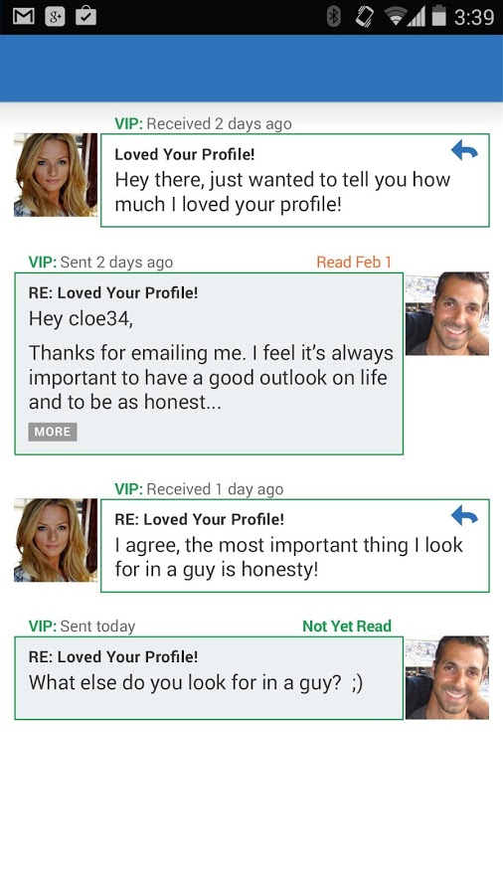 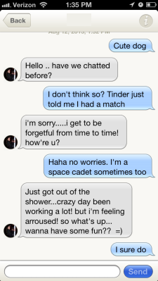

Apps Analyzed:

* OkCupid
* PlentyofFish
* Tinder

Private messaging allows users to contact other users in an email or text message fashion via the dating app platform. Some of the benefits of private messaging is that it allows users to have faster private contact between each other. Furthermore, Users can get a feel for who the person is beyond their profile description the downside of private messaging is that since there is no face to face contact, users cannot fully grasp facial expressions, body language, or sarcasm. The user might be afraid of initiating the private messaging because they’re afraid of being ignored it can also be difficult to converse with a user that receives a lot of messages.

“Viewed Me”

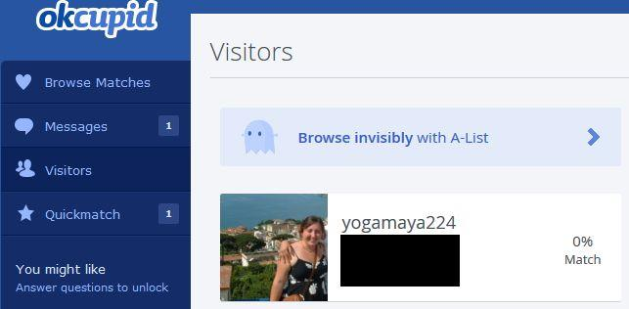

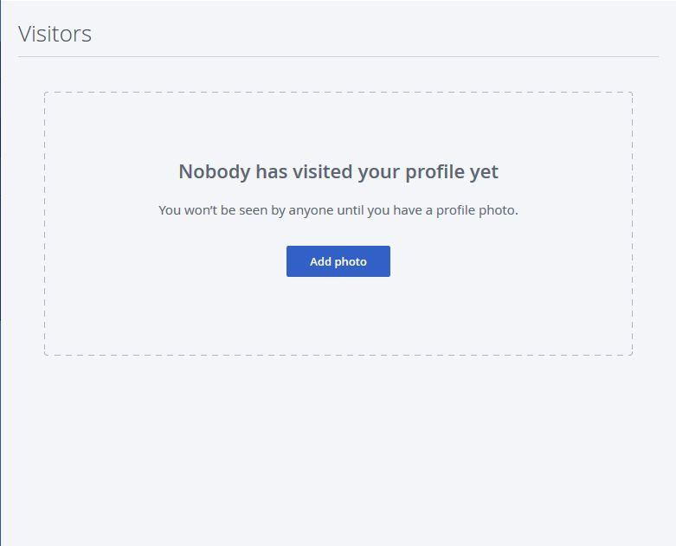

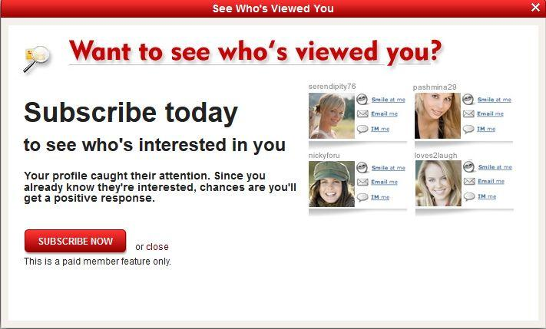

Apps Analyzed:

* OkCupid
* Lavalife

“Viewed Me” gives users the ability to see other users that have visited their profile page. Viewed me helps the user evaluated anywhere from secret admirers to stalkers. Some benefits of viewed me is that you’re able to see users that have visited your profile and have remained silent, showing potential stalkers. Viewed me can also be used to gauge the attractiveness of your profile based on how many other users are visiting. Some Cons of viewed me is that no anonymous browsing since the other users know when someone is visiting their profile and accidentally clicking on profile or simply browsing a profile can show false interest.

Computer Algorithm Matching

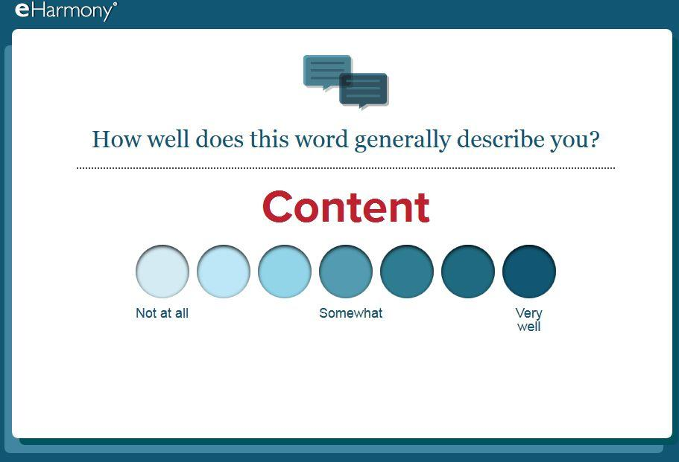 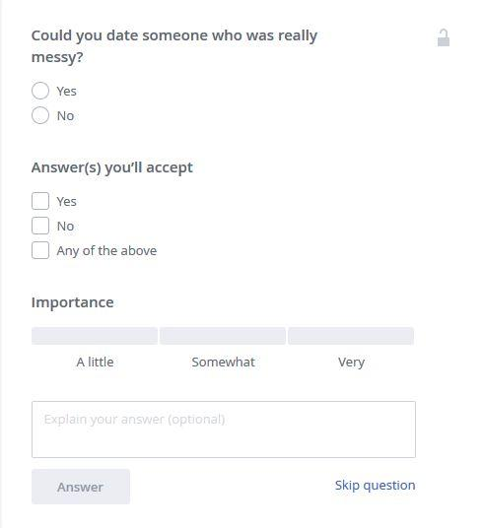



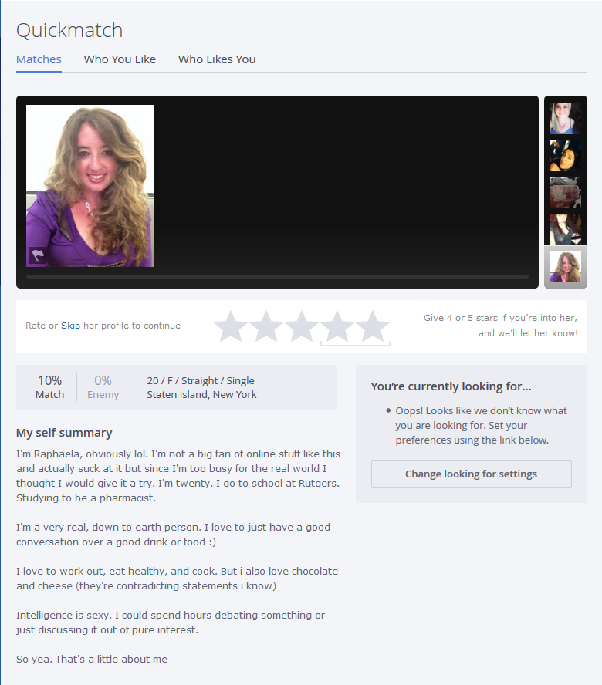

Computer algorithm matching is a service that will recommend other users to a user that could potentially be a good match based on their profile information.

Apps Analyzed:

* OkCupid
* Match.com

Pros:

* Can be used to quickly find someone that the system thinks is a match for the user
* Shows instant matches based on set preferences for physical attributes, removing the hassle of inputting them every time

Cons:

* Takes a lot of time and effort in order to answer the questionnaires
* It does not account for Out-of-Date Users
* Algorithm can be incorrect, it can match users that are not good matches
* Users can doubt the accuracy of the algorithm; a match will only be good if the users believe it is
* The algorithm limits the users it shows, potentially hiding the right match

Social Media Connectivity

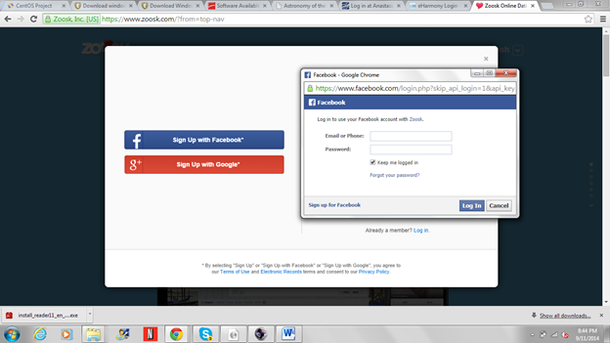

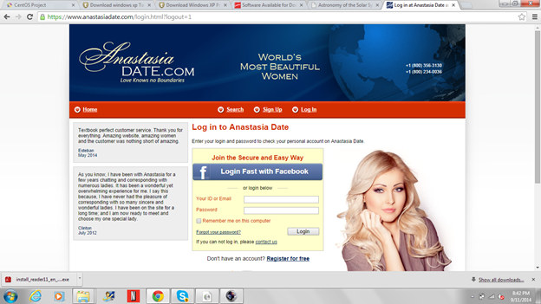

Social media connectivity is the ability or requirement for a user to link an existing social media account to their dating app account.

Apps Analyzed:

* Zoosk
* AnastasiaDate
* Tinder

Pros:

* Easy profile creation and importing of information
* The applications use mutual connections increasing the chance of a relationship, since someone is more likely to go out with a friend of a friend

Cons:

* Excludes people who do not have a social media account
* Users don’t trust giving out their personal social media account information

Mobile Support

 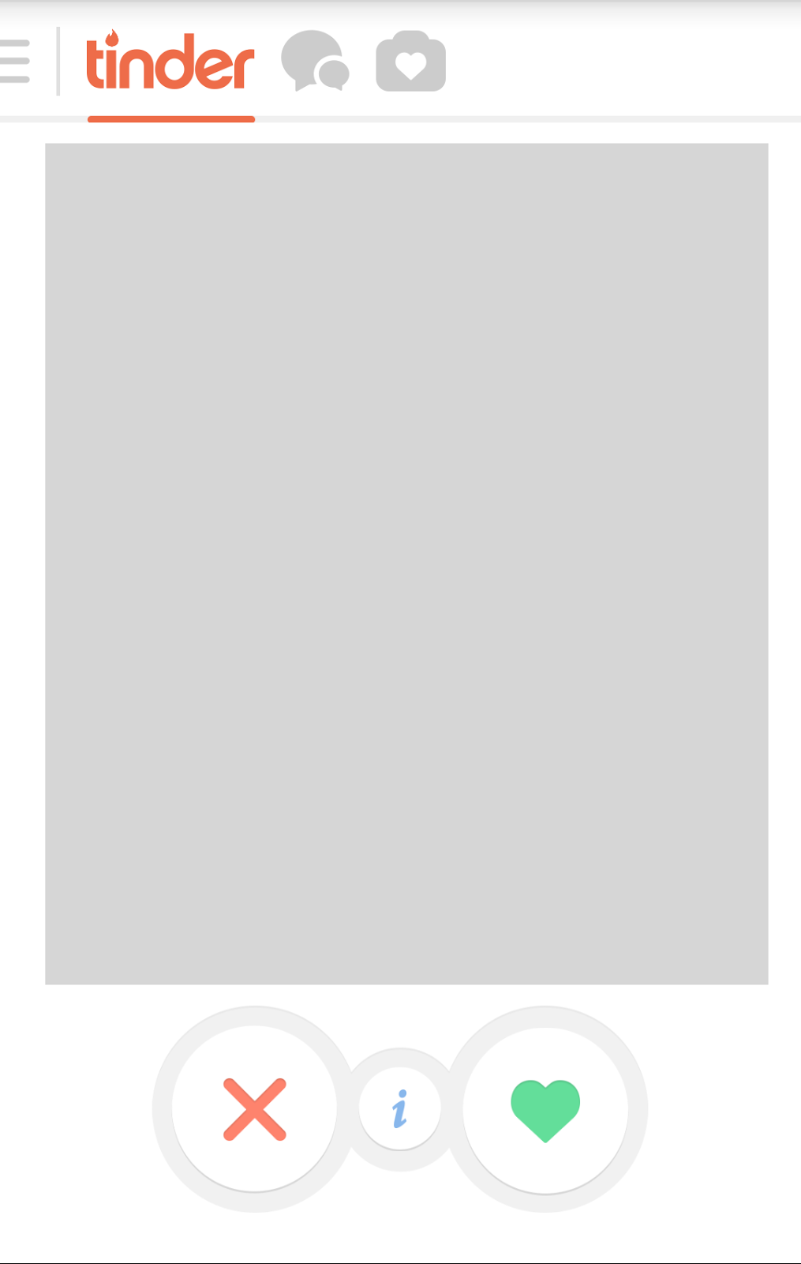

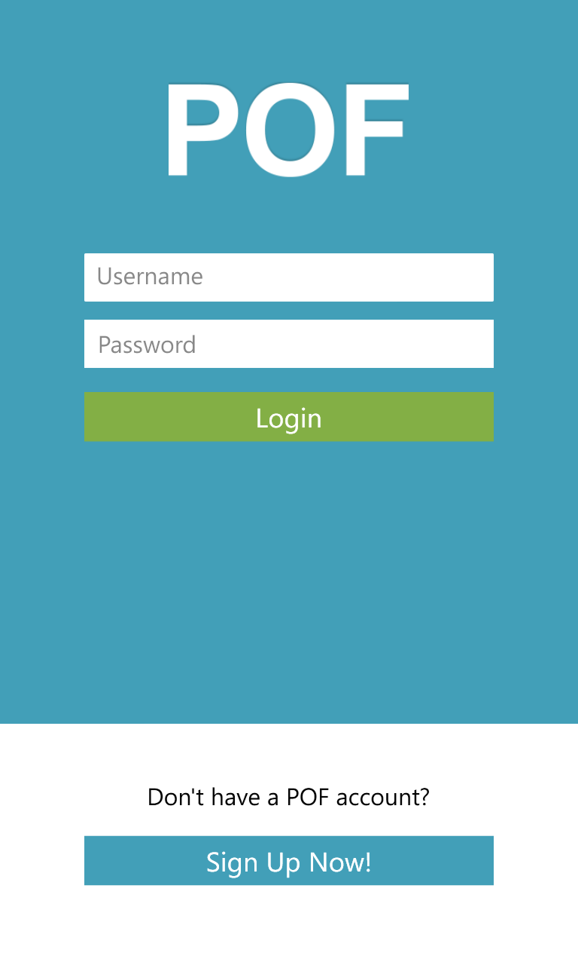

Apps Analyzed:

* Tinder
* OkCupid
* PlentyofFish

Mobile support is when a dating service has a mobile application or website available for their users to make use of on their mobile device. Some benefits of mobile support is that users aren’t limited to the desktop version alone. The app can be used from many more locations since users have their phone everywhere. Furthermore, since it is more easily accessible, users can use it at their convenience. Mobile support has some downside, some apps like Tinder are solely mobile based and can exclude users that do not have a mobile device.

Like / Star

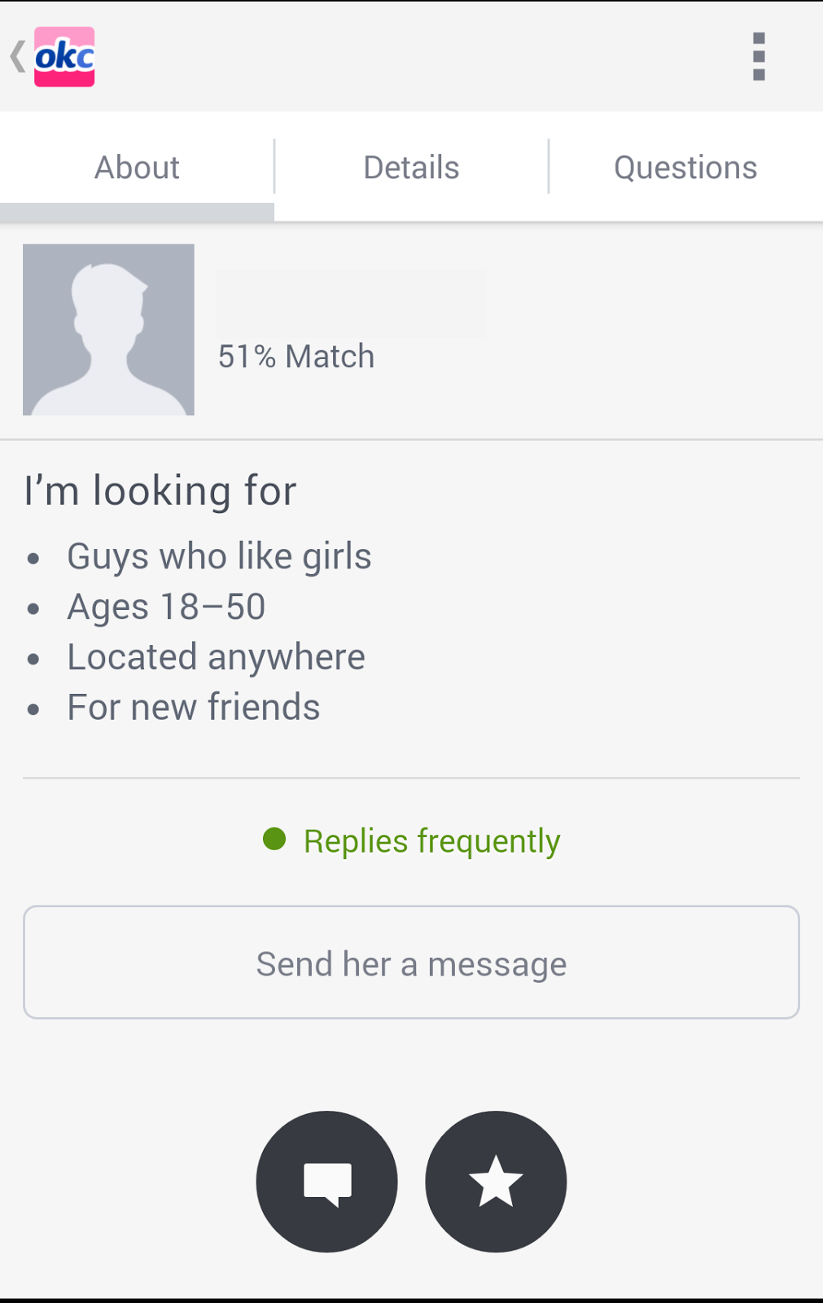 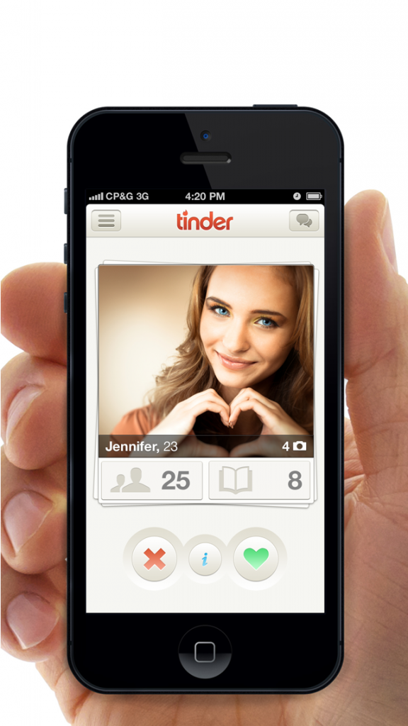



Apps Analyzed:

* OkCupid
* Tinder
* PlentyofFish

“Liking” or “Favoring” means you found a particular person attractive or you wished to save their profile to easily have access to their profile. Liking or favoring can be used to generate a list of users to be viewed later. Furthermore, liking in apps likes Tinder means you found that person attractive and if that person likes you back the app enables the private messaging function the downside of Liking and favoring is that it’s not a mode of communication, the function doesn’t provide any real interaction between users.and last, it does not show any serious interest towards users.

Real Time Notification

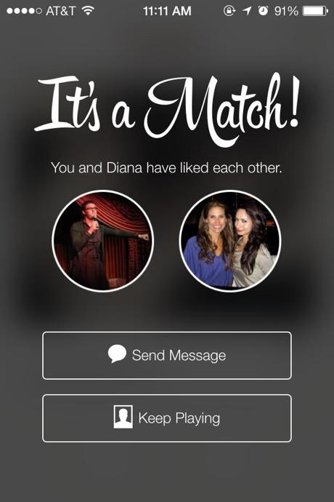 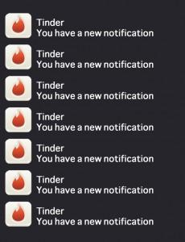

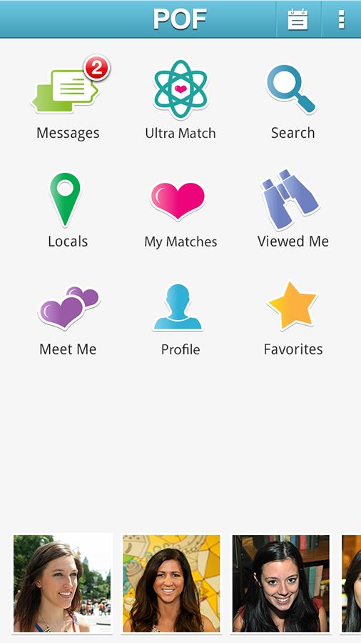

Real time notifications provide an instant notification to the user if someone messages or has some form of interaction with them.

Apps Analyzed:

* Tinder
* OkCupid
* Zoosk

Pros:

* Users won’t miss out on the messages and can reply faster
* Avoids the hassle of constantly looking at the application to see if someone has messaged or has some form of interaction

Cons:

* The application can send constant “spam” notifications in an attempt to have the user use the application more often, annoying them in the process

Analyzed Literature

**The Filtered Encounter: Online Dating and the Problem of Filtering Through Excessive Information**

By Kirsty Best and Sharon Delmege

http://eds.a.ebscohost.com.libdb.njit.edu:8888/eds/pdfviewer/pdfviewer?sid=1de39d96-f7e0-41c2-92b5-201cadb0f88a%40sessionmgr4005&vid=2&hid=4213

* The large network of people on dating sites had led to **information overload** due to too many profiles, too much information, and too many potential romantic partners
* Filtering through the many options, partners, and choices has become a prime concern of users
* More focused on *filtering* *out* unsuitable partners than on *catching* potential mates
* “Shopping culture” of dating has been created; users are simply browsed through like merchandise
* Self-presentation tactics and strategies of searching profile commentary and photographs become the most important

**The Truth about Lying in Online Dating**

By Jeffrey T. Hancock, Catalina Toma, and Nicole Ellison

https://www.msu.edu/~nellison/hancock_et_al_2007.pdf

As online dating grow in popularity, so does the lies being interchange by it users. Online dating has provided it users with the ability to be perceived as a better self. Granting them the facility to be seen as that ideal people, while hiding their true flaws behind a mobile device or a computer.

People lie about their physical attributes, specifically height, weight and age, on their profile, something that is nearly impossible if you were to meet someone in person. The survey yield out interesting results but not to surprising, men look for youth and physical attractiveness in their partners, whereas women look for education and career. Furthermore, women lie more about their age and weight whereas men often lie about their height which is often associated with power and status. And finally two-thirds of the participants’ weight was inaccurate by 5 pounds or more.

**Who Visits Online Dating Sites? Exploring some Characteristics of Online Daters**

By Patti M. Valkenburg and Jochen Peter

http://eds.a.ebscohost.com.libdb.njit.edu:8888/eds/pdfviewer/pdfviewer?sid=1de39d96-f7e0-41c2-92b5-201cadb0f88a%40sessionmgr4005&vid=10&hid=4213

* Online dating sites allows the user to control their self presentation
* Online dating was irrelevant to income and education level
* People between the age of 30 - 50 were the most active users
* It is much easier to stop talking to someone without feeling guilty
* Online dating has evolved to mainstream social practice
* This paper talks about two opposing hypotheses:
  + Social compensation hypothesis, which explains that people with higher dating anxiety benefit more from online dating because there is no face to face conversation involved
  + The rich-get-richer hypothesis explains that people with low dating anxiety benefit from online dating because they see it as just another way of finding a partner

**An Experiment Investigating the Links Among Online Dating Profile Attractiveness, Ideal Endorsement, and Romantic Media**

By Veronica Hefner and Julie Kahn

http://www.sciencedirect.com/science/article/pii/S0747563214002313

In the article, Veronica Hefner and Julie Kahn conducted an experiment investigating the links among online dating profile attractiveness, Ideal endorsement, and romantic media. Their experiments which was based on the feedback from 249 college students yield out interesting results, one of their conclusion was that exposure to romantic media are related to profile attractiveness, romantic beliefs, and endorsement of ideal partner characteristics. Basically, people will based their ideal person on their perception of someone from the media like a famous celebrity. Furthermore, consuming romantic media predicted stronger endorsement of romantic beliefs and higher ratings of profile attractiveness. The experiment finally concluded that People who watch romantic movies and consume other romantic media have been exposed to romantic ideology and philosophy